**Data Report**

**Children, Money, and Happiness**

**Introduction:**

Happiness and satisfaction are some of the most important things people aspire in their lives; and often aspects such as financial income and offspring become avenues to achieve them. This paper examines the correlation, if any, between the different income level and happiness in India. While doing that, it also seeks to analyse the satisfaction rates amongst the Indian and the American populace with regard to their economic conditions. It then tries to find and compare the average number of children people have in countries like India, China, the USA, and Brazil. This report sources its data from the World Values Survey Wave 6. Microsoft Office Excel 2013 and JASP 0.8.4.0 were used to analyse and draw conclusions from the data.

**Research Question 1:**

Is there a difference between the satisfaction levels regarding their financial condition between people from India and USA? In other words, are Americans more satisfied with their financial situation than Indians?

**Null Hypothesis (H0):** There is no significant difference between people’s satisfaction with their financial condition in India and USA. (µIndia = µUSA)

**Alternate Hypothesis (H1):** People are more satisfied with their financial condition in either USA or India. (µIndia ≠ µUSA)

**Methods:**

People were asked to rate their satisfaction with the financial situation of their household on a scale of 1 to 10 – one being the least satisfied (completely dissatisfied) and ten being completely satisfied. There were 5642 valid observations from India and 2216 valid observations from USA. An independent samples t-test was conducted on JASP with a α-value of 0.05 to test for significant difference with country as the grouping variable and financial satisfaction as the dependent variable.

| **Descriptive Statistics:** | | | | |
| --- | --- | --- | --- | --- |
|  | Financial Satisfaction | | | |
|  | India | | USA | |
| Mean |  | 5.644 |  | 6.305 | |  |
| Median |  | 6.000 |  | 7.000 | |  |
| Mode |  | 5.000 |  | 8.000 | |  |
| Std. Deviation |  | 2.490 |  | 2.398 | |  |
|  | | | | |

**Financial Satisfaction Boxplot:**

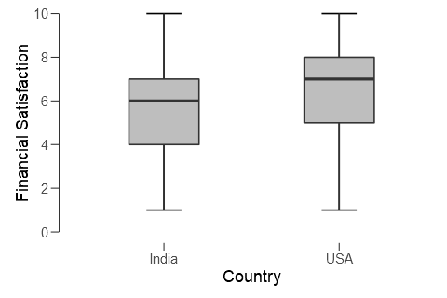

| **Independent Samples T-Test:** | | | | | | | | | |
| --- | --- | --- | --- | --- | --- | --- | --- | --- | --- |
|  | | Test | | Statistic | | df | p | | |
| Financial Satisfaction |  | Student |  | -10.69 |  | 7856 |  | < .001 |  | |
|  |  | Mann-Whitney |  | 5.231e +6 |  |  |  | < .001 |  | |
|  | | | | | | | | | |

| **Group Descriptives:** | | | | | | | | | | |
| --- | --- | --- | --- | --- | --- | --- | --- | --- | --- | --- |
|  | | Group | | N | | Mean | | SD | SE | |
| Financial Satisfaction |  | India |  | 5642 |  | 5.644 |  | 2.490 |  | 0.033 |  |
|  |  | USA |  | 2216 |  | 6.305 |  | 2.398 |  | 0.051 |  |
|  | | | | | | | | | | |

**Financial Satisfaction Plot:**

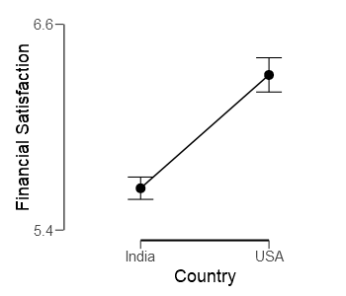

The error bars display 95% confidence intervals. There is no overlap between them which implies that errors cannot explain the difference between the means.

**Conclusion:**

With a p value of less than 0.001 and an α-value of 0.05, we reject the null hypothesis and conclude that people are more satisfied with their financial condition in USA.

**Research Question 2:**

Is there a difference in the average number of children that people have in India, China, USA, and Brazil? Do Indians have more children on average than people from other countries?

**Null Hypothesis (H0):** There is no significant difference between the number of children that people have among the four countries. (µIndia = µUSA = µBrazil = µChina) Any variations can be explained by chance.

**Alternate Hypothesis (H1):** There is a significant difference between the number of children that people have among the four countries. (µIndia ≠ µUSA ≠ µBrazil ≠ µChina) The difference between the means is substantial.

**Methods:**

Data was collected about the number of children people have from question V58 of the WVS questionnaire. One way ANOVA was conducted with number of children as the dependent variable and countries as the fixed factors. Post-hoc tests were conducted using Tukey and Bonferroni corrections and descriptive plots with error bars were plotted keeping the countries on the horizontal axis.

| **Descriptive Statistics:** | | | | | | | | | |
| --- | --- | --- | --- | --- | --- | --- | --- | --- | --- |
|  | | Number of Children | | | | | | | |
|  | | Brazil | | China | | India | | USA | |
| Mean |  | 2.005 |  | 1.453 |  | 2.342 |  | 1.757 |  |
| Median |  | 2.000 |  | 1.000 |  | 2.000 |  | 2.000 |  |
| Std. Deviation |  | 1.786 |  | 1.063 |  | 1.624 |  | 1.609 |  |
| Variance |  | 3.190 |  | 1.131 |  | 2.638 |  | 2.589 |  |
| Minimum |  | 0.000 |  | 0.000 |  | 0.000 |  | 0.000 |  |
| Maximum |  | 8.000 |  | 7.000 |  | 8.000 |  | 8.000 |  |
|  | | | | | | | | | |

**Descriptive Boxplots:**

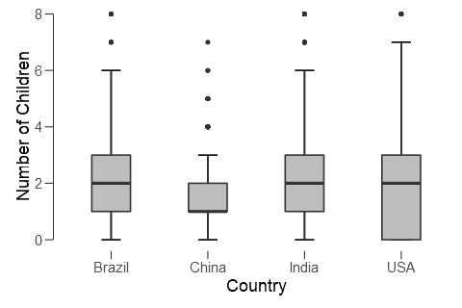

| **ANOVA - Number of Children** | | | | | | | | | | | |
| --- | --- | --- | --- | --- | --- | --- | --- | --- | --- | --- | --- |
| Cases | | Sum of Squares | | df | | Mean Square | | F | | p | |
| Country |  | 1446 |  | 3 |  | 482.139 |  | 201.2 |  | < .001 |  |
| Residual |  | 27247 |  | 11373 |  | 2.396 |  |  |  |  |  |
|  | | | | | | | | | | | |
| *Note.*  Type III Sum of Squares | | | | | | | | | | | |

| **Test for Equality of Variances (Levene's)** | | | | | | | |
| --- | --- | --- | --- | --- | --- | --- | --- |
| F | | df1 | | df2 | | p | |
| 124.6 |  | 3 |  | 11373 |  | < .001 |  |
|  | | | | | | | |

| **Post Hoc Comparisons – Country:** | | | | | | | | | | | | | | | |
| --- | --- | --- | --- | --- | --- | --- | --- | --- | --- | --- | --- | --- | --- | --- | --- |
|  | |  | | Mean Difference | | SE | | t | | p tukey | | p scheffe | | p bonf | |
| Brazil |  | China |  | 0.552 |  | 0.052 |  | 10.711 |  | < .001 |  | < .001 |  | < .001 |  |
|  |  | India |  | -0.337 |  | 0.045 |  | -7.419 |  | < .001 |  | < .001 |  | < .001 |  |
|  |  | USA |  | 0.248 |  | 0.052 |  | 4.783 |  | < .001 |  | < .001 |  | < .001 |  |
| China |  | India |  | -0.889 |  | 0.039 |  | -23.040 |  | < .001 |  | < .001 |  | < .001 |  |
|  |  | USA |  | -0.304 |  | 0.046 |  | -6.589 |  | < .001 |  | < .001 |  | < .001 |  |
| India |  | USA |  | 0.585 |  | 0.039 |  | 14.967 |  | < .001 |  | < .001 |  | < .001 |  |
|  | | | | | | | | | | | | | | | |

**Descriptives Plot:**

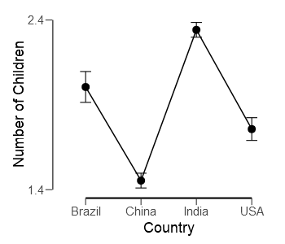

The error bars display 95% confidence intervals. There is no overlap between them which implies that errors cannot explain the difference between the means.

**Conclusion:**

An F-statistic value of 201.2 indicates that data is spread out away from the means, indicating that we should reject the null hypothesis. We reject the null hypothesis and accept the alternate, as the p-value (<0.001) is less than α (0.05). This means that there is a significant difference in the number of children that people have according to country. Post-hoc tests were conducted to check for variances between individual countries. These concluded that there is a significant difference between all four countries (with a p-value of 0.001) when it comes to number of children that people have. China scores the lowest, thanks to its one child policy that was recently abolished. Meanwhile, Indians, as expected, have the maximum number of children.

**Research Question 3:**

Is there a correlation between Income levels and happiness in India? Do people belonging to a certain income group lead happier lives?

**Null Hypothesis (H0):** There is no correlation between income levels and happiness in India. Coefficient of the predictor variable (Income group) or slope will be equal to zero.

**Alternate Hypothesis (H1):** There is a correlation, either positive or negative, between income levels and happiness in India. Coefficient of the predictor variable (Income group) or slope will not be equal to zero.

**Methods:**

People were asked to rate their general happiness on a scale of 1 to 4, one being very happy and four being not at all happy. They were also asked which income group they belonged to, on a scale of 1 to 10, one being the lowest income group in the country, and ten being the highest. Linear regression was performed on the data with Happiness as the dependent variable and Income group as the covariate. Significance was set at 5%. Excel was used to plot the data and generate the line of best fit.

**Linear Regression:**

| **Model Summary** | | | | | | | | | | | | | |
| --- | --- | --- | --- | --- | --- | --- | --- | --- | --- | --- | --- | --- | --- |
| Model | | R | | | R² | | | Adjusted R² | | RMSE | | | |
| 1 |  | 0.138 |  | | 0.019 |  | | 0.019 |  | 0.730 | |  | |
|  | | | | | | | | | | | | | |
| **ANOVA** | | | | | | | | | | | | | | |
| Model | |  | | Sum of Squares | | df | | Mean Square | | F | | p | | |
| 1 |  | Regression |  | 58.10 |  | 1 |  | 58.101 |  | 109.1 |  | < .001 |  | |
|  |  | Residual |  | 2971.26 |  | 5577 |  | 0.533 |  |  |  |  |  | |
|  |  | Total |  | 3029.36 |  | 5578 |  |  |  |  |  |  |  | |
|  | | | | | | | | | | | | | | |

| **Coefficients** | | | | | | | | | | | | | |
| --- | --- | --- | --- | --- | --- | --- | --- | --- | --- | --- | --- | --- | --- |
| Model | |  | | Unstandardized | | Standard Error | | Standardized | | t | | p | |
| 1 |  | (Intercept) |  | 2.003 |  | 0.022 |  |  |  | 92.05 |  | < .001 |  |
|  |  | Income Group |  | -0.045 |  | 0.004 |  | -0.138 |  | -10.44 |  | < .001 |  |
|  | | | | | | | | | | | | | |

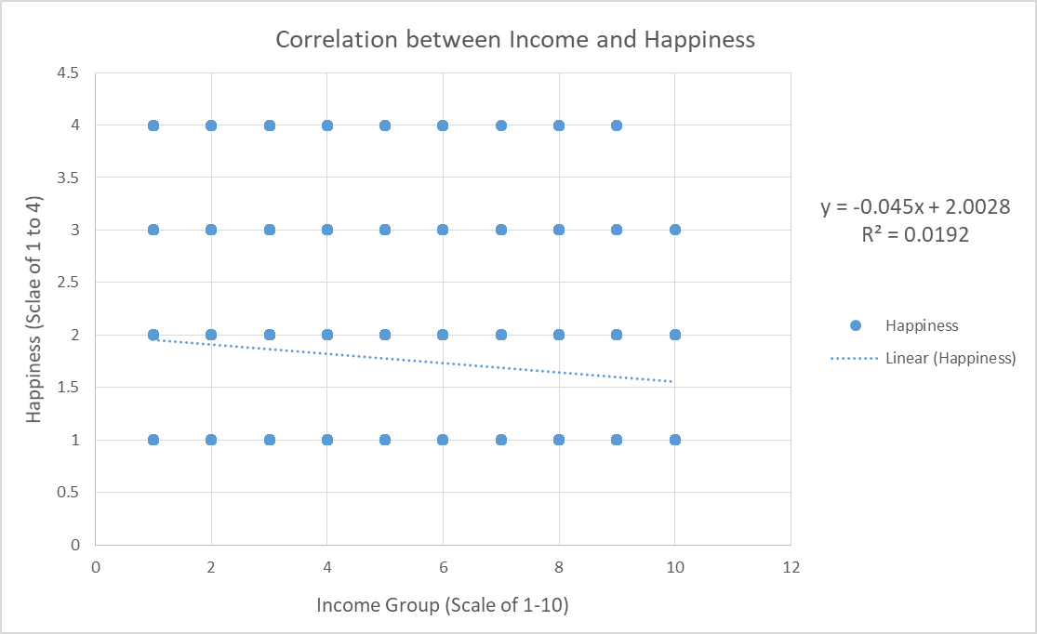

**Correlation Plot**

**Conclusion:**

The R2 value is extremely low, indicating that the model isn’t robust enough. Thus we can’t use income groups to predict happiness with accuracy. The coefficient of Income Group is only -0.045, thus indicating that with increase in income, people become happier (lower value on the scale means greater happiness. But since the R2 value is low, the model is not accurate, and thus, no real conclusions can be made.